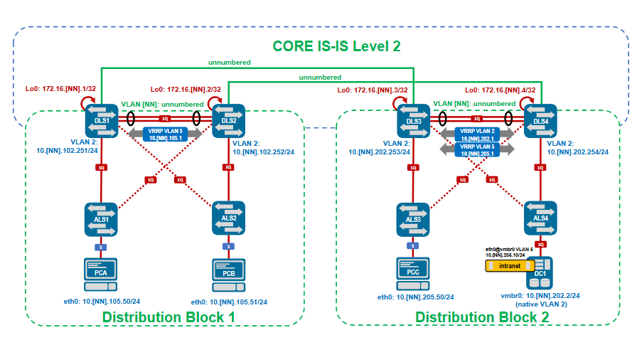
2220

sh vlan
sh route
sh interfaces vlan2
sh mac address-table vlan 2

Kaikille als1-4
spanning-tree mode rpvst
spanning-tree
spanning-tree vlan 1,2

Kaikkiin dls1-4

spanning-tree mode rapid-pvst

Dls1 ja 3
spanning-tree vlan-id 1-4094 root primary

dls2 ja 4
spanning-tree vlan-id 1-4094 root secondary

Step 2

NN46-DLS1(config)#int vlan 2
NN46-DLS1(config-if-Vl2)#vrrp 2 priority-level 120

NN46-DLS2(config)#int vlan 2
NN46-DLS2(config-if-Vl2)#vrrp 2 priority-level 80

ALS1
vlan 5
name OFFICE
exit
spanning-tree vlan 5

DLS jakelu muille DLS1 konffi

interface Vlan5
ip address 10.46.105.251/24
isis enable LAN
isis passive
vrrp 5 priority-level 120
vrrp 5 ipv4 10.46.105.1
!

Secondary DLS

interface Vlan2
ip address 10.46.102.252/24
isis enable LAN
isis passive
vrrp 2 priority-level 80
vrrp 2 ipv4 10.46.102.1

Muuta 2 ->5

interface Vlan5
ip address 10.46.105.252/24
isis enable LAN
isis passive
vrrp 5 priority-level 80
vrrp 5 ipv4 10.46.105.1

DLS3

interface Vlan5
ip address 10.46.205.252/24
isis enable LAN
isis passive
vrrp 5 priority-level 120
vrrp 5 ipv4 10.46.205.1
!

DLS4
interface Vlan5
ip address 10.46.205.252/24
isis enable LAN
isis passive
vrrp 5 priority-level 80
vrrp 5 ipv4 10.46.205.1
!

vlan 5
name OFFICE
spanning-tree vlan 5

Step2 check

ALS1-3
int 1/1/3
vlan access 5
no shutdown

ALS4
vlan trunk allowed all
vlan trunk native 2

DC1

ping 10.46.202.1

Kaikille als1-4
ALS1
spanning-tree mode rpvst
spanning-tree
spanning-tree vlan 1,2

vlan 5
name OFFICE
exit
spanning-tree vlan 5

int 1/1/3
vlan access 5
no shutdown

ALS2

spanning-tree mode rpvst
spanning-tree
spanning-tree vlan 1,2

vlan 5
name OFFICE
exit
spanning-tree vlan 5

int 1/1/3
vlan access 5
no shutdown

ALS3

spanning-tree mode rpvst
spanning-tree
spanning-tree vlan 1,2

vlan 5
name OFFICE
exit
spanning-tree vlan 5

int 1/1/3
vlan access 5
no shutdown

ALS4
spanning-tree mode rpvst
spanning-tree
spanning-tree vlan 1,2

vlan 5
name OFFICE
exit
spanning-tree vlan 5

int 1/1/3
vlan trunk allowed all
vlan trunk native 2

DLS1

spanning-tree mode rapid-pvst
spanning-tree vlan-id 1-4094 root primary

int vlan 2
vrrp 2 priority-level 120

vlan 5
name OFFICE

interface Vlan5
ip address 10.46.105.251/24
isis enable LAN
isis passive
vrrp 5 priority-level 120
vrrp 5 ipv4 10.46.105.1

DLS2
spanning-tree mode rapid-pvst
spanning-tree vlan-id 1-4094 root secondary
int vlan 2
vrrp 2 priority-level 80

vlan 5
name OFFICE

interface Vlan5
ip address 10.46.105.251/24
isis enable LAN
isis passive
vrrp 5 priority-level 80
vrrp 5 ipv4 10.46.105.1

DLS3

spanning-tree mode rapid-pvst
spanning-tree vlan-id 1-4094 root primary
int vlan 2
vrrp 2 priority-level 120

vlan 5
name OFFICE

interface Vlan5
ip address 10.46.205.252/24
isis enable LAN
isis passive
vrrp 5 priority-level 120
vrrp 5 ipv4 10.46.205.1

DLS4
spanning-tree mode rapid-pvst
spanning-tree vlan-id 1-4094 root secondary
int vlan 2
vrrp 2 priority-level 80

vlan 5
name OFFICE

interface Vlan5
ip address 10.46.205.252/24
isis enable LAN
isis passive
vrrp 5 priority-level 80
vrrp 5 ipv4 10.46.205.1

PCA
ping
10.46.105.50

